Assignment #19: Modes of Heat Transfer

1. What are the three main modes of heat transfer?

2. What is a fluid?

3. What is the main mode of heat transfer that takes place in solids?

4. What is the main mode of heat transfer that takes place in fluids?

5. Which mode of heat transfer does not require a medium?

6. Draw the methods of heat transfer that are present in the picture below. Label each of them.

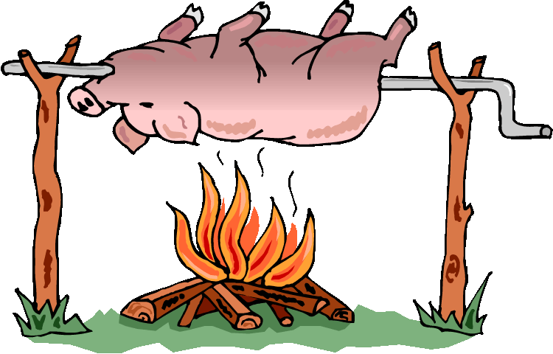

7. Label the main method of heat transfer that is taking place in each situation.
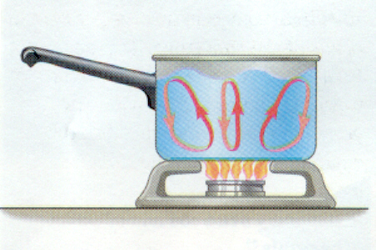
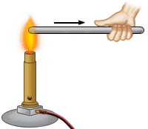
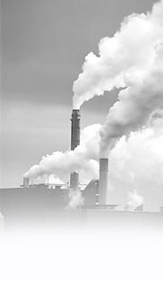

8. Identify the type of heat transfer that is taking place in each situation:

______________ The sun shines on a car

______________ A pot of water begins to boil.

______________ A man cooks a hamburger on a grill.

______________ A mechanic burns himself on a hot engine.

______________ An air conditioner blows cold air.

______________ Liquid nitrogen circulates in a tank.

______________ The road heats up in the sunlight.

______________ A copper rod burns a person's hand when heated on the opposite side.

